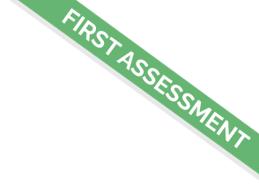

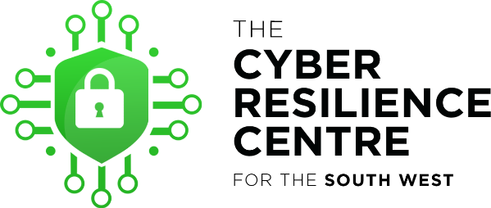

First Step Web Assessment

Website Assessed:

Report Submitted:

Student Assessor:

Introduction to First Step Web Assessment Service
We thank you for entrusting your Cyber needs with the team at the SWCRC. Our unique partnership between Policing, Business & Academia strives to support organisations like yours on their journey to Cyber Resilience. We recognise that for many of you this may be the first time you have considered contracting a cyber service and therefore our team are incredibly focused to ensure you truly recognise the value in our initiative and this service provision.
Our ‘First Step Web Assessment’ has been designed by our experienced private sector security team to not only provide you with an initial assessment of your website but to also provide our cadre of cyber students an opportunity to further develop their skills under the strict management of our supervising team. Whilst this service is not a full penetration test or vulnerability test it does offer an invaluable view on your website.

Our Assessment
On this engagement our student team assessed the website –
This assessment was completed by our student XXXXXXX on XXXXXXXXXXX.
Our students delivered this assessment using mainstream assessment tools and carefully following our considered first step web assessment methodology.

Our Findings
On completing the assessment our team assessed the output and present the following findings.
The Positive Elements of Your Website
1 | Website name is due to renew next year (15th Nov 2022.)
2 | Your website hides version information for the software responsible with making it accessible on the Internet, this prevents an attacker from using this information to ascertain vulnerabilities in your website.
3 | Important security headers are implemented on your website, this establishes browser security defences and makes it harder for some vulnerabilities to be exploited.

Elements That May Require Further Investigation
1 | Components used to create and provide functionality to your website may be outdated and may contain vulnerabilities that can be exploited by attackers.
2 | Traffic communicated between the site is encrypted using a currently acceptable standard of encryption, however the site also allows web browsers to use older versions of encryption that have been compromised and can no longer securely protect communications.
3 | The certificate on your website responsible for encrypting the traffic is due to expire soon (6th Nov 2021.)
4 | Emails sent from your website address (e.g., joe.bloggs@com.net) are not fully protected against impersonation. Your email provider may be able to assist you in implementing this protection.
5 | Multiple areas of interest related to your website are easily identified. In changing the common path to these areas an attacker cannot easily identify how to access them.

What Should I Do Next?
We may have shared a few points from our assessment that would benefit from further investigation. This is all part of the journey to greater Cyber Resilience! But what should you do next? Well, having now completed the assessment our team remain focused on helping you further, and the next step is to arrange an assessment meeting with you where we can talk through our findings and help you make an informed decision on how to proceed. You may need the help of your web developers or your managed service provider, but regardless, our team at SWCRC are on hand to work in collaboration as we all now strive to improve the resilience of your website.

Let’s Talk…
When you have had a moment to review our findings, please do contact SWCRC Enquiries at enquiries@swcrc.co.uk, who will gladly make the meeting arrangements at a time and date that works for you. We look forward to speaking with you.

